SRM Institute of Science and Technology  College of Engineering and Technology



**Batch 2**

**Set D**

DEPARTMENT OF ECE

SRM Nagar, Kattankulathur – 603203, Chengalpattu District, Tamilnadu

**Academic Year: 2024-2025 (Even)**

**Test: FT- III Date: 03.04.2025**

**Course Code / Title:21ECC302T/ Analog and Digital Communication Duration:12.30 – 2.15PM**

**Year & Sem:III&VI Max. Marks:50**

**Course Articulation Matrix:**

|  |  |  |  |  |  |  |  |  |  |  |  |  |  |  |  |  |
| --- | --- | --- | --- | --- | --- | --- | --- | --- | --- | --- | --- | --- | --- | --- | --- | --- |
|  | **21ECC302T/ Analog and Digital Communication** | **PROGRAM OUTCOMES (PO)** | | | | | | | | | | | | **PROGRAM SPECIFIC OUTCOMES** | | |
| **S.NO** | **COURSE OUTCOMES** | **1** | **2** | **3** | **4** | **5** | **6** | **7** | **8** | **9** | **10** | **11** | **12** | **1** | **2** | **3** |
| 1 | Explain the Various Analog Modulation Techniques | 3 | - | - | - | - | - | - | - | - | - | - | 2 | 2 | - | - |
| 2 | Analyze the Noise performance of Radio transmitters and Receivers | 3 | 3 | - | - | - | - | - | - | - | - | - | 2 | - | 3 | - |
| 3 | Demonstrate the demodulation and detection of received digital data | 3 | 2 | - | - | - | - | - | - | - | - | - | - | - | - | 3 |
| 4 | Apply the suitable passband techniques for real time applications | 3 | - | - | - | 3 | - | - | - | - | - | - | - | - | - | 2 |
| 5 | Exposed to the concepts of information theory and  channel capacity | 3 | - | 3 | - | - | - | - | - | - | - | - | - | 3 | - | - |

|  |  |  |  |  |
| --- | --- | --- | --- | --- |
| **Q. No** | **Part A (11x1=11 Marks) Answer ALL the question** | **Marks** | **BL** | **CO** |
| **1** | If a PCM system uses 8 bits per sample and has a sampling rate of 8 kHz, what is the bit rate?  **a) 64 kbps** b) 32 kbps c) 16 kbps d) 128 kbps | **1** | **2** | **3** |
| **2** | A PCM system has a maximum input voltage of 5V and a minimum voltage of -5V. It uses 8-bit quantization. What is the step size of the quantizer?  a) 0.02 V **b) 0.04 V** c) 0.08 V d) 0.1 V | **1** | **2** | **3** |
| **3** | The main purpose of a matched filter in a communication system is to:   1. Reduce noise in the channel. 2. **Maximize the signal-to-noise ratio (SNR).** 3. Minimize the bit error rate. 4. Amplify weak signals. | **1** | **1** | **3** |
| **4** | Inter Symbol Interference (ISI) occurs due to:  a) Channel noise **b) Overlapping of successive symbols**  c) Insufficient quantization levels d) Low sampling rates | **1** | **1** | **3** |
| **5** | A major drawback of Delta Modulation (DM) is:  a) Quantization noise **b) Slope overload distortion**  c) High complexity d) Low bandwidth efficiency | **1** | **1** | **3** |
| **6** | If a BPSK signal has a carrier frequency of 100 MHz and a data rate of 5 Mbps, what is the spectral bandwidth of the BPSK signal?  a) 2.5 MHz **b) 5 MHz** c) 10 MHz d) 20 MHz | **1** | **2** | **4** |
| **7** | The probability of error in Quadrature Phase Shift Keying (QPSK) is given by:    **a) Pe=**𝟏 𝒆𝒓𝒇𝒄 %&𝑬𝒃 ' b) Pe=1 𝑒𝑟𝑓𝑐 %&&𝐸𝑏'  𝟐 𝑵𝟎 & 𝑁$ | **1** | **2** | **4** |

|  |  |  |  |  |
| --- | --- | --- | --- | --- |
|  | c) Pe=𝑒𝑟𝑓𝑐(√&𝐸𝑏) d) Pe=1 𝑒𝑟𝑓𝑐(√ 𝐸𝑏 )  𝑁$ & &𝑁$ |  |  |  |
| **8** | Which of the following has the highest bandwidth efficiency?  a) BPSK b) QPSK c) 8-PSK **d) 16-PSK** | **1** | **1** | **4** |
| **9** | is a passband modulation technique   1. Pulse Amplitude Modulation (PAM) 2. **Frequency Shift Keying (FSK)** 3. Pulse Code Modulation (PCM) 4. Delta Modulation (DM) | **1** | **1** | **4** |
| **10** | A 16-QAM system has how many distinct symbols?  a) 4 b) 8 **c) 16** d) 32 | **1** | **2** | **4** |
| **11** | Which modulation scheme has the lowest bit error rate (BER) for a given signal-to-noise ratio (SNR)?  **a) BPSK** b) QPSK c) 16-PSK d) BFSK | **1** | **1** | **4** |
| **Part B (3x8=24 Marks) Answer ALL the question** | | | | |
| **12. a.** | Explain Pulse Amplitude Modulation (PAM) and describe how a PAM signal is generated and demodulated, including the necessary waveforms.  **Answer:**  **(Explanation of PAM with diagram 2 Marks)**   * In *pulse-amplitude modulation* (PAM), *the amplitudes of regularly spaced pulses are varied in proportion to the corresponding sample values of a continuous message signal*; the pulses can be of a rectangular form or some other appropriate shape. * Pulse-amplitude modulation as defined here is somewhat similar to natural sampling, where the message signal is multiplied by a periodic train of rectangular pulses. However, in natural sampling the top of each modulated rectangular pulse varies with the message signal, whereas in PAM it is maintained flat * The waveform of a PAM signal is illustrated in Figure 3.1. The dashed curve in this figure depicts the waveform of a message signal *m(t ),* and the sequence of amplitude modulated rectangular pulses shown as solid lines represents the corresponding PAM signal *s(t )* * For transmission of digital data is discrete pulse amplitude modulation(PAM). In discrete PAM, the amplitude of the pulse varies in discrete manner according to the input binary data. * The discrete PAM can have only two amplitude levels corresponding to binary ‘1’ and ‘0’. Successive binary bits can be combined into symbols. There can be multiple amplitude levels corresponding to these symbols. They generate discrete PAM signals. * These signals can be transmitted (without any modulation) over the channel in baseband transmission. * In PAM, amplitude of pulses is varied in accordance with instantaneous value of modulating signal. | **8** | **3** | **3** |

|  |  |  |  |  |
| --- | --- | --- | --- | --- |
|  | **PAM Generation (Explanation- 1 Mark ; diagram 2 Marks)**   * The circuit is simple emitter follower., In the absence of the clock signal, the output follows input.The modulating signal is applied as the input signal. Another input to the base of the transistor is the clock signal. The frequency of the clock signal is made equal to the desired carrier pulse train frequency. * The amplitude of the clock signal is chosen the high level is at ground level(0v) and low level at some negative voltage sufficient to bring the transistor in cutoff region. * When clock is high, circuit operates as emitter follower and the output follows in the input modulating signal. When clock signal is low, transistor is cutoff and output is zero. Thus the output is the desired PAM signal.     **PAM Demodulation (Explanation- 1 Mark ; diagram 2 Marks)**    Reconstruction of pulse signal    PAM demodulator   * A PAM (Pulse Amplitude Modulation) demodulator recovers the original message signal from a modulated waveform. |  |  |  |

|  |  |  |  |  |
| --- | --- | --- | --- | --- |
| **12. b.** | * It consists of an envelope detector and a second-order op-amp low pass filter. * The envelope detector, made using a diode, capacitor, and resistor, tracks the amplitude variations of the PAM pulses and converts the amplitude information into a continuous signal. * The second-order low pass filter, designed using an operational amplifier, provides sharper roll-off and better high-frequency noise attenuation. * It effectively removes the sampling frequency and residual carrier components. * Compared to a first-order filter, the second-order filter is more effective in noise reduction. * This ensures accurate retrieval of the original message signal. * PAM demodulators are widely used in analog communication systems, data transmission, and audio signal processing. * Combining an envelope detector and a second-order filter enhances demodulation performance, making it reliable for various practical applications.   **(OR)**  With neat diagram, explain the working of Delta modulation.  **Answer:**  **Delta modulation Concept (2 Marks)** | **8** | **2** | **3** |

|  |  |  |  |  |
| --- | --- | --- | --- | --- |
|  | **(Diagram 1 Mark) (Transmitter Diagram 1 Mark: Expression with Explanation 2 Marks)** |  |  |  |

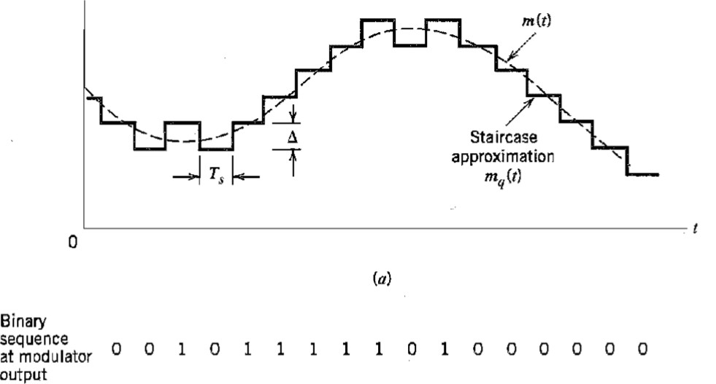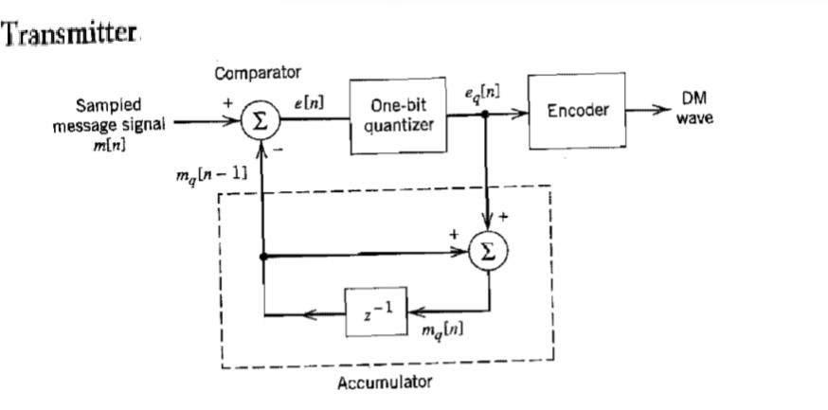

|  |  |  |  |  |
| --- | --- | --- | --- | --- |
|  | **(Receiver Diagram 1 Mar;kExplanation 1 Mark)** |  |  |  |
| **13. a.** | i. Explain the operations of Pulse Code Modulation (PCM) with the help of a block diagram.  **Answer:**  **(Block Diagram 2 Marks; Explanation 2 Marks)**    Block diagram of Pulse Code Modulation (PCM)   * **Sampling:**   + The message signal is sampled using narrow pulses to approximate instantaneous values.   + Sampling rate must exceed twice the highest frequency component for accurate reconstruction. * **Quantization:**   + Converts sampled values to discrete levels using non-uniform quantization (e.g., µ-law, A-law). * **Encoding:**   + Maps quantized values to codewords using a specific coding scheme. * **Regeneration:**   + Regenerative repeaters correct distortions and noise through equalization, timing adjustment, and decision-making.   + They restore the original signal apart from minor errors due to noise and jitter. | **4** | **2** | **3** |

|  |  |  |  |  |
| --- | --- | --- | --- | --- |
|  | * **Decoding:**   + Converts codewords back to quantized values, forming a Pulse Amplitude Modulated (PAM) signal. * **Filtering:**   + A low-pass filter with a cutoff at the message bandwidth reconstructs the original signal.   ii. A Television signal with a bandwidth of 4.2 MHz is transmitted using binary PCM. The number of quantization levels is 512. Calculate, (a) Code word length **(1 Mark)**, (b)Final bit rate **(2 Marks)** and Transmission bandwidth **(1 Mark)**  **Answer:**    **(1 Mark)**  The final bit rate will equal to signaling rate. The signaling rate is given as,      **(2 Marks)**  The transmission bandwidth is obtained as,    **(1 Mark)**  **(OR)** | **4** | **3** | **3** |

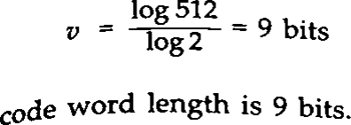

|  |  |  |  |  |
| --- | --- | --- | --- | --- |
| **13. b.** | Draw the waveforms for a binary sequence 0110100 modulated under QPSK.  **Answer:**  **(8 Marks)** | **8** | **3** | **4** |
| **14. a.** | i. With neat diagrams, explain the concept of M-ary PSK transmitter and receiver.  **Answer:**  **In M-ary PSK, the carrier phase takes on one of the M possible values, namely** q**i = 2 * (i - 1)**p **/ M**  **where i = 1, 2, 3, …..M.**  **The modulated waveform can be expressed as**    **where Es is energy per symbol = (log2 M) Eb Ts is symbol period = (log2 M) Tb.**  **The above equation in the Quadrature form is**    **By choosing orthogonal basis signals**      **M-ARY PSK Transmitter (Diagram 1 Mark; Explanation 1 Mark)** | **4** | **2** | **4** |

|  |  |  |  |  |
| --- | --- | --- | --- | --- |
|  | **Input Binary Data (b(t))**:  The input is a stream of binary data (0s and 1s).  **Serial to Parallel Converter**:  This block converts the incoming serial bit stream into **N parallel bit streams**.  **Digital to Analog Converter (DAC)**:  The parallel data is converted into an analog signal that represents a unique value or symbol. Each unique symbol corresponds to a specific phase in the constellation diagram.  **Sinusoidal Signal Source and Phase Modulator**:  A carrier wave (sinusoidal signal) is generated. The phase modulator shifts the phase of the carrier wave based on the analog signal.This results in an **M- ary PSK modulated signal**.  **Output M-ary PSK Signal**:  The modulated signal is transmitted over the communication channel. Each symbol carries log2M bits of information, providing efficient data transmission.  **M-ARY PSK Receiver (Diagram 1 Mark; Explanation 1 Mark)**    Uses a reference carrier signal that is phase-aligned with the transmitted signal.  **I/Q Demodulation**: Separates the signal into in-phase and quadrature components for accurate detection.  **Phase Discrimination**: Determines the most likely transmitted symbol based on phase shifts.  **Efficient for M-PSK**: Works for BPSK (M=2), QPSK (M=4), 8-PSK (M=8), and higher-order PSK.  This receiver efficiently demodulates M-PSK signals by **extracting phase information** from the received signal.  ii. Explain the difference between M-PSK and M-QAM in terms of constellation diagrams.  **Answer:**    **Constellation Diagram for M-PSK (1 ½ Marks)and M-QAM (1 ½ Marks)**  **Any two differences 1 Mark (½ Mark for each)** | **4** | **3** | **3** |

|  |  |  |  |  |
| --- | --- | --- | --- | --- |
| **14. b.** | **(OR)**  Describe the generation and detection of binary FSK signal with necessary diagram and equation.  **Answer:**  **Generation of FSK (2 Marks – Diagram; 2 Marks - Explanation with Expressions)**    In a binary FSK system symbol ‘1’ and ‘0’ are transmitted as    Frequency  for some fixed integer nc and i=1, 2 The basic functions are given by  Therefore FSK is characterized by two dimensional signal space with two message points i.e. N=2 and m=2.  The two message points are defined by the signal vector     * The incoming binary data sequence is applied to on-off level encoder. * The output of encoder is *√Eb* volts for symbol 1 and 0 volts for symbol ‘0’. * When we have symbol 1 the upper channel is switched on with oscillator frequency f1, for symbol ‘0’, because of inverter the lower channel is switched on with oscillator frequency f2. * These two frequencies are combined using an adder circuit and then transmitted. | **8** | **2** | **4** |

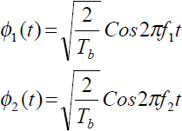

|  |  |  |  |  |
| --- | --- | --- | --- | --- |
|  | **DETECTION OF FSK (2 Marks – Diagram: 2 Marks- Explanation)**     * The detector consists of two correlators. * The incoming noisy BFSK signal x(t) is common to both correlator. * The Coherent reference signal Փ1(t) *and* Փ2(t) are supplied to upper and lower correlators respectively. * The correlator outputs are then subtracted one from the other and resulting a random vector ‘l’ (l=x1 - x2). * The output ‘l’ is compared with threshold of zero volts. * If l > 0, the receiver decides in favor of symbol 1. * l < 0, the receiver decides in favor of symbol 0. |  |  |  |
| **Part C (1x15=15 Marks) Answer ALL the question** | | | | |
| **15. a.** | Derive the expression for the error probability of matched filter.  **Answer:**    **(upto this 2 Marks)** | **15** | **4** | **3** |

|  |  |  |  |  |
| --- | --- | --- | --- | --- |
|  |  |  |  |  |

|  |  |  |  |  |
| --- | --- | --- | --- | --- |
|  |  |  |  |  |

|  |  |  |  |  |
| --- | --- | --- | --- | --- |
|  | **(upto Average probability of symbol error 8 Marks)** |  |  |  |

|  |  |  |  |  |
| --- | --- | --- | --- | --- |
|  | **(4 Marks)** |  |  |  |

|  |  |  |  |  |
| --- | --- | --- | --- | --- |
| **15. b.** | **(1 Mark) (OR)**   1. In digital CW communication system, the bit rate of NRZ data stream is 1 Mbps and carrier frequency is 100 MHz. Find the symbol rate of transmission and bandwidth requirement of the channel in the following cases of different techniques used. (1) BPSK system (2) QPSK system (3)16ary PSK system. **(6 Marks)**   **Answer:**   * 1. **BPSK system (2 Marks-> Symbol rate 1 Mark BW 1 Mark)**   2. **QPSK system (2 Marks-> Symbol rate 1 Mark BW 1 Mark) (3)16ary PSK system (2 Marks-> Symbol rate 1 Mark BW 1 Mark)** | **15** | **4** | **4** |

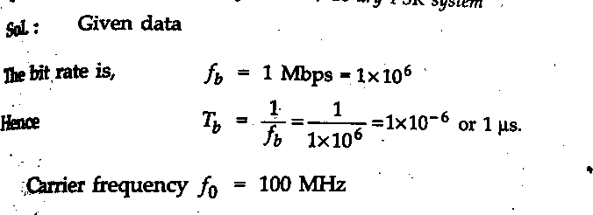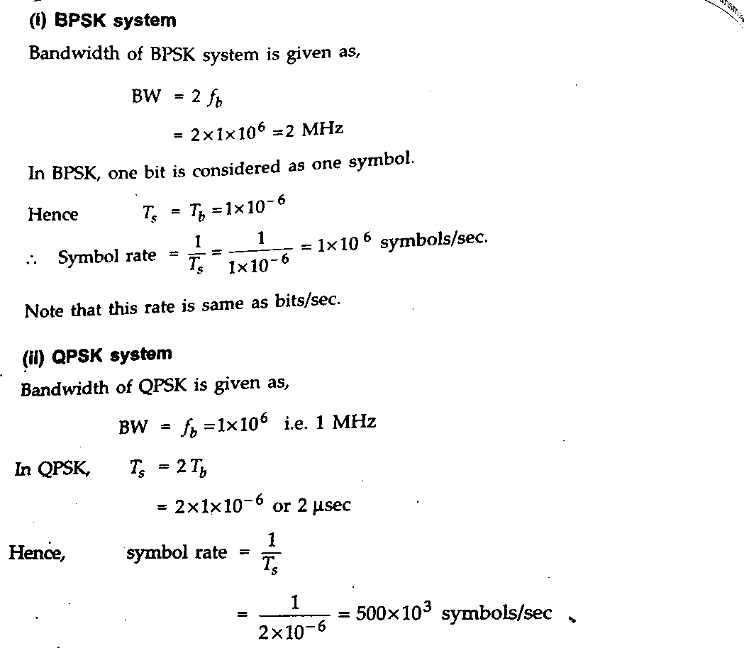

|  |  |  |  |  |
| --- | --- | --- | --- | --- |
|  | (b) Draw the constellation diagram of FSK, PSK and QPSK. **(6 Marks)**  **(2 Marks)**        **(2 Marks)** |  |  |  |

|  |  |  |  |  |
| --- | --- | --- | --- | --- |
|  | Fig. Signal Space Representation of QPSK **(2 Marks)**  (c) Differentiate coherent and non-coherent detection. **(3 Marks)**  **Coherent Detection** and **Non-Coherent Detection**:  **Any 3 Difference 3 Marks** |  |  |  |

Course Outcome (CO) and Bloom’s level (BL) Coverage in Questions

**CO Coverage (%)**

|  |  |  |
| --- | --- | --- |
| **Aspect** | **Coherent Detection** | **Non-Coherent Detection** |
| **Synchronization** | Requires carrier phase synchronization | No phase synchronization needed |
| **Complexity** | Higher due to synchronization circuits | Lower and simpler receiver design |
| **Performance (BER)** | Lower (better performance) | Higher (worse performance) |
| **Spectral Efficiency** | Higher | Lower |
| **Noise Sensitivity** | More sensitive to phase noise | Less sensitive to phase noise |
| **Receiver Type** | Requires coherent demodulator | Uses envelope or differential detector |
| **Power Consumption** | Higher | Lower |
| **Examples** | BPSK, QPSK, QAM | FSK, DPSK, ASK |
| **Applications** | High data rate systems (e.g., 5G) | Low complexity systems (e.g., Satellite Communication) |
| **Cost** | More expensive | More economical |

**100**

**80**

**100**

**80**

**BL Coverage (%)**

**60 60**

**40 40**

**20**

**0**

**CO1 CO2 CO3 CO4 CO5**

**20**

**0**

**BL1**

**BL2**

**BL3**

**BL4**

Evaluation Sheet

Name of the Student: Register No.:

|  |  |  |  |  |
| --- | --- | --- | --- | --- |
| **Part- A (11x 1= 11 Marks)** | | | | |
| **Q.**  **No** | **CO** | **Maximum Marks** | **Marks Obtained** | **Total** |
| 1 | 3 | 1 |  |  |
| 2 | 3 | 1 |  |
| 3 | 3 | 1 |  |
| 4 | 3 | 1 |  |
| 5 | 3 | 1 |  |
| 6 | 4 | 1 |  |
| 7 | 4 | 1 |  |
| 8 | 4 | 1 |  |
| 9 | 4 | 1 |  |
| 10 | 4 | 1 |  |
| 11 | 4 | 1 |  |  |
| **Part – B (3 x 8 = 24 Marks)** | | | | |
| 12 a | 3 | 8 |  |  |
| 12 b | 3 | 8 |  |
| 13 a | 3 | 8 |  |
| 13 b | 4 | 8 |  |
| 14 a | 4 | 8 |  |
| 14 b | 4 | 8 |  |
| **Part - C (1 x 15 = 15 Marks)** | | | | |
| 15 a | 3 | 15 |  |  |
| 15 b | 4 | 15 |  |  |

Consolidated Marks:

|  |  |  |
| --- | --- | --- |
| **CO** | **Maximum**  **Marks** | **Marks**  **Obtained** |
| **3** | **44** |  |
| **4** | **45** |  |
| **Total** | **89** |  |

Signature of Course Teacher

Signature of the Course Coordinator Signature of the Academic Advisor